A Comprehensive Analysis of Crew Productivity

In this paper, I will accomplish several goals. First, I will provide an overview of crew productivity given current labor estimates and assumptions. Second, I will construct new production functions based on actual crew performance data as measured by T-sheets. Finally, I will put these production functions in the context of job profitability and make a recommendation for implementation.

The Data: The data for this analysis comes primarily from Switcher and T-sheets.

Switcher: Switcher divides all measures into two categories: insulation and mechanical. A table of all the measures and the corresponding crew-type is included at the end of this report. The insulation crew rate is $30 per hour. The mechanical crew rate is $35 per hour.

For each job in the data set, the following data points were gathered:

1. The total contract amount measured in dollars
2. The total contract amount measured in dollars for mechanical work
3. The total contract amount measured in dollars for insulation work
4. The total budgeted hours spent by insulation crews
5. The total budgeted hours spent by mechanical crews
6. The total drive time budgeted for insulation crews
7. The total drive time budgeted for mechanical crews
8. Hours budgeted for furnace, duct, A/C and water heater installs

The same data was gathered for all signed change orders.

T-Sheets: The entire T-sheets dataset was exported as a .CSV file. The variables in the original file that were included in the analysis were:

1. The crew member (ex. Edgar Guzman)
2. The job code or job name (ex. Daniel Shepstone),
3. The amount of hours spent on the job that day (ex. 5.76 hours)

Each crew member was assigned to either the insulation or mechanical crew depending on the nature of their work that day. After tallying the total amount of time each crew member spent at each job site, the total insulation and mechanical hours was calculated for each job code.

Cleaning the Data: There a variety of reasons that the T-sheets data is not 100% accurate. There are numerous reasons for it to be biased in the upwards and downward direction. However, this is not a reason to dismiss the data entirely. I rigorously examined the data for a number of errors. Projects were excluded for the following reasons:

1. Work began prior to the company-wide adoption of T-sheets on March 1st , 2014
2. Work had not been 100% closed out and paid in full by April 1st, 2015
3. Payments to AHE differed from the contract amount by $1000 or more
4. The project involved measures for which Switcher did not estimate hours (ex. Solar PV, solar Thermal, boiler, electrical)
5. AHE was working as a subcontractor to a general contractor

By excluding projects meeting any of the above criteria (and more), I cut the data from over 60,000 crew-hours to under 25,000 hours, from 328 job codes to 148, for a total of $1,623,310. I consider this to be our “bread-and-butter” work.

Overview of Crew Productivity for Insulation

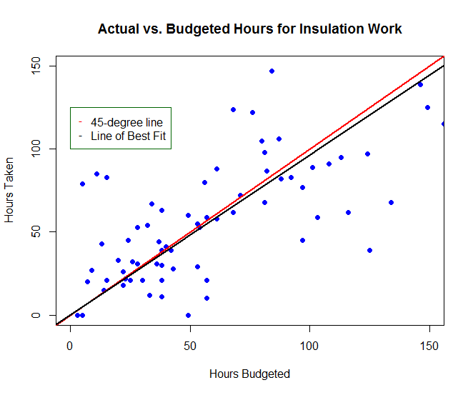

The scatterplot above shows the relationship between the amount of hours budgeted by Switcher (on the X-axis) and the amount of hours taken per T-sheets (on the Y-axis) for insulation work. We’re looking at 123 jobs and approximately 8,000 hours of work.

The red line is the “45-degree line.” For the purposes of this analysis, any observation that falls on the 45 degree line is predicted perfectly given current assumptions. In other words, the amount of hours budgeted equals the amount of hours taken. Any observation that falls below the 45-degree line took less time than budgeted. Any observation that falls above the 45-degree line took longer than budgeted.

The black line is the “line of best fit”- the regression of x on y. It is almost identical to the 45-degree line. This is ideal- it shows that Switcher is nearly as accurate as the line of best fit in predicting the duration of time spent on the jobsite. The regression tells us that for every hour budgeted, 0.965 hours are actually spent.

While there is clearly some variation around the line that can be further investigated, this is beyond the scope of this report. Recommendations for future investigation will be made in the conclusion.

Overview of Crew Productivity for Mechanical Work

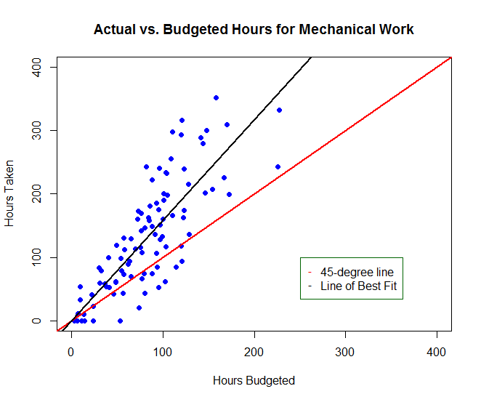

The scatterplot above shows the relationship between hours budgeted and hours taken for mechanical work. We are looking at 95 jobs and approximately 14,000 hours of work.

Unlike insulation, most mechanical jobs run over the budgeted hours. This is indicated by the fact that most observations are above the 45-degree line. A regression line shows the line of best fit and it clearly differs from what is ideal. For every hour budgeted, the crew spends about 1.6-1.8 hours on the job site.

New Production Functions for Mechanical Work

It is clear from the overview that we are underestimating how long mechanical work will take given current assumptions. In this section, I will construct completely new production functions using multivariate statistical regression. The dependent variable is the amount of time the mechanical crews spent according to T-sheets. The measures I included in my analysis were:

1. Furnace installs and replacements
2. Duct installs and replacements
3. Air conditioners
4. Tankless water heaters

For heat pumps in particular, the air handler unit is included as a furnace measure and the condensing unit is included as an A/C. This reflects the set-up in Switcher and provides for a consistent interpretation of the data.

Because other mechanical work was often performed as part of the workscope, I added a variety of controls to the model. These controls are intended to provide more accurate estimates of the four key measures listed above:

1. Asbestos abatement
2. Bath fans
3. New grilles
4. Mechanical engineering
5. Zoning
6. HRV/ERV

In addition to the controls above, I included a variable measuring the remaining total mechanical hours budgeted *after* factoring out the hours budgeted for the key measure. This allows us to control for other smaller measures, such as a gas shut-off valve or CAZ fix.

The interpretation of the coefficient of determination ${(R}^{2})$ is as follows: An $R^{2}$ of 1 means that the hours estimated per the model perfectly match how long the job actually took. As this declines

This analysis will include several models of increasing complexity. First, we will start with a baseline estimate of average time per measure. Second, we will include drive time as a factor. Third, we will investigate variable-level hour estimates in aggregate. Fourth, we will investigate variable-level hours estimates in particular.

Model 1: Average Time by Measure

The goal of the first model is to estimate how long each of the key measures take on average. The results are reported below. All measures are statistically significant to the 99th percentile.

|  |  |  |
| --- | --- | --- |
| Measure | Average Time (hrs) | Std. Dev (hrs) |
| Furnace | 30 | 12 |
| Ducts | 99 | 12 |
| A/C | 116 | 18 |
| Tankless | 94 | 14 |
| df=75 |  |  |
| $R^{2}$ =0.93 |  |  |

Model 2: Average Time by Measure Including Drive Time

The next prediction model includes drive time, which *a priori* should affect job duration and crew productivity. The amount of drive time was derived by measuring the number of miles between the warehouse and the job address.

|  |  |  |
| --- | --- | --- |
| Measure | Average Time (hrs) | Std. Dev (hrs) |
| Furnace | 36 | 12 |
| Ducts | 84 | 12 |
| A/C | 99 | 18 |
| Tankless | 93 | 14 |
| Distance (mi) | .98 | 0.5 |
| df=75 |  |  |
| $R^{2}$ =0.932 |  |  |

The data shows that for every additional mile that the job address is from the warehouse, the job took 0.98 hours longer overall. The statistical significance of drive time is at the 90% level. By including the drive time, the average job time A/C installs declined. This is consistent with the idea that there is a A/C installs typically take place in hotter climates that are further from the office.

Furthermore, I divided the job addresses into different territories, ex. South Bay, far East Bay, etc. However, these models did not provide statistically significant estimates of drive time on job duration. I believe part of the reason for this is that I did not have enough data from various territories to provide a robust estimate.

Model 3: Measure-Specific Production Functions

The inputs to this model are the amount of time budgeted per measure per job (ex. 37.5 hours for a furnace). We can call these variables “measure-specific.” The outputs of this model are therefore also measure-specific.

The ultimate goal of a production function is to be not measure specific (ex. furnace) but *variable specific* (ex. condensate pump, new pad). Although this model includes measure-specific outputs,the budgeted amount of time for each measure is in fact variable specific in aggregate. For example, the 37.5 hours budgeted for a furnace includes the time bid to install a condensate pump, etc. Therefore, the model outputs should be interpreted as the amount of time that needs to be added to each measure given current values of measure-specific variables.

The goal of the third prediction model is to estimate how many hours need to be added to each measure overall in order to have the budgeted hours most closely match the actual hours.

|  |  |
| --- | --- |
| Measure | Underestimate (%) |
| Furnace | 40% |
| Ducts | 68% |
| A/C | 255% |
| Tankless | 174% |
| df=74 |  |
| $R^{2}$ =0.948 |  |

Based on this output, we can calculate how many hours the average install should take in order to reach parity between budgeted and predicted hours.

|  |  |  |  |  |
| --- | --- | --- | --- | --- |
| Measure | Average Budgeted Hours | Recommended Budgeted Hours | Increase in Avg. Hours | Sample Size |
| Furnace | 36 | 51 | 15 | 58 |
| Ducts | 42 | 71 | 29 | 81 |
| A/C | 31 | 80 | 49 | 10 |
| Tankless | 35 | 62 | 27 | 15 |

The conclusion of this paper will investigate the pricing effects of adding these hours to the bid.

Model 4: Variable-Specific Production Functions

Besides an estimate of average time, other features of the house must be taken into account in order to create the most accurate bid. Many of these variables are included in Switcher. The goal of the final model in this analysis is to create a production function that accounts for some of these variables. The variables included in this model are:

1. Furnaces: new, replacement, gravity furnace replacement
2. Furnaces: install location
3. Ducts: # of wireflex runs
4. Ducts: # of KD runs
5. Ducts: # of cut-ins
6. A/C: New or Replacement

The results of the model are as follows.

For furnaces: new and gravity furnaces took 10-14 hours longer to install than furnace replacements. Compared to an attic installation, crawlspace and garage installations took 7-15 hours less while mechanical closets took 11 hours more. However, none of the variables were statistically significant.

For ducts: A wireflex duct took 1.7 hours to install and a KD duct took 2.5 hours. Neither of these estimates is statistically significant. A new cut-in took 4 hours on average and this result is significant at the 90% level.

For A/C: A replacement A/C took 60 hours to install, approximately half the time for a new A/C, 126 hours.

Recommendations and Implementation

By adjusting the average prices for the key measures per model 3, we can much more accurately predict how long mechanical work will take with 95% accuracy where jobs are mis-bid by no more than 30 hours on average.

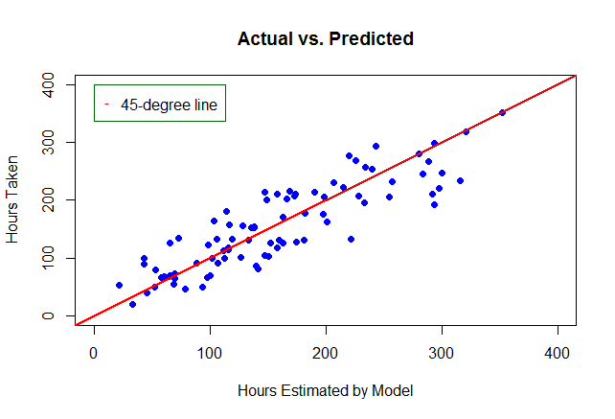

In order to bring our estimates in line with reality, I recommend increasing the hours of our mechanical measures by the rates estimated in the aggregate variable-level model (model 3). We can do this by either a flat hours transfer or spreading the hours across different variables.

For furnaces, I recommend an across the board hours increase by 15 hours for new and replacement installs for an average cost of $5,000 per furnace including materials. Some of these hours can be transferred to attics and mechanical closet installs.

For ductwork, we need to increase average hours by 30 hours per job, from approximately $2770 to $4500 in labor. I recommend increasing the cost of cut-ins from 1 hour to 4 hours. I recommend stricter definitions of accessibility.

For A/C’s, I recommend charging much more for new systems, adding approximately 50 additional hours or $3,700. A lesser increase for replacements is warranted as well. Some sales training on airflow can save time, as can training the crew on diagnostic testing.

Finally, for tankless water heaters, I recommend adding 27 hours to the flat rate for around $6,000 on average. Training on gas line sizing may help salespeople to discriminate more effectively by pricing gas-line sizing separately.

Finally, implementing a sales cap system in Switcher whereby the “low bid” is our current pricing scheme and the default “new bid” is the updated pricing scheme would be a Pareto-efficient way to nudge salespeople into charging more.